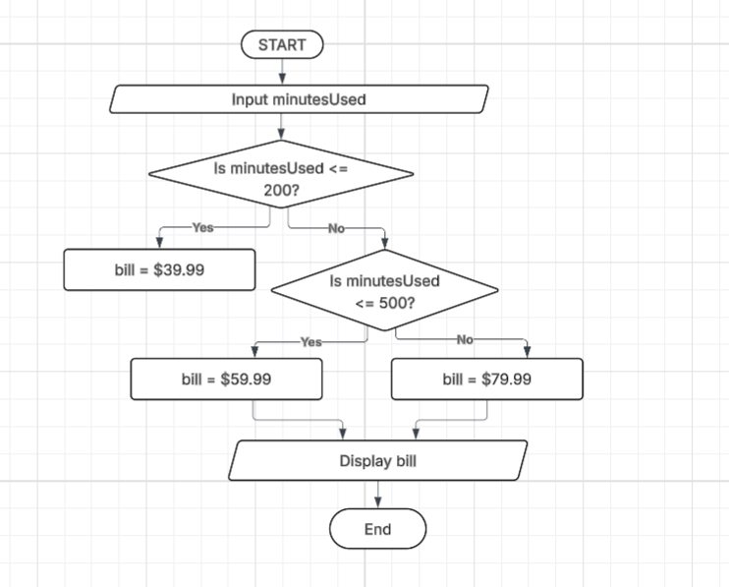
Dash Cell Phone Company Exercise

